Tasking Manager Tasks to FMTM
Object Sequence Diagram
@startuml
Participant “Tasking Manager” as TM
Participant “Field Mapping Task Manager” as FMTM
TM -> FMTM: Create(TM Tasks incl Task Id)
FMTM -> FMTM: Create FTM Tasks for contiguous region
FMTM -> FMTM: Map TM Tasks to FTM Subtasks>
loop for each non-contigious region
FMTM -> FMTM: Create FTM Tasks for contiguous region
FMTM -> FMTM: Map TM Tasks to FTM Subtasks
end

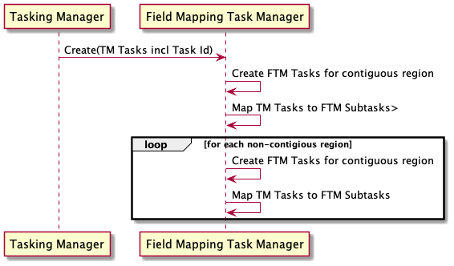
@enduml

